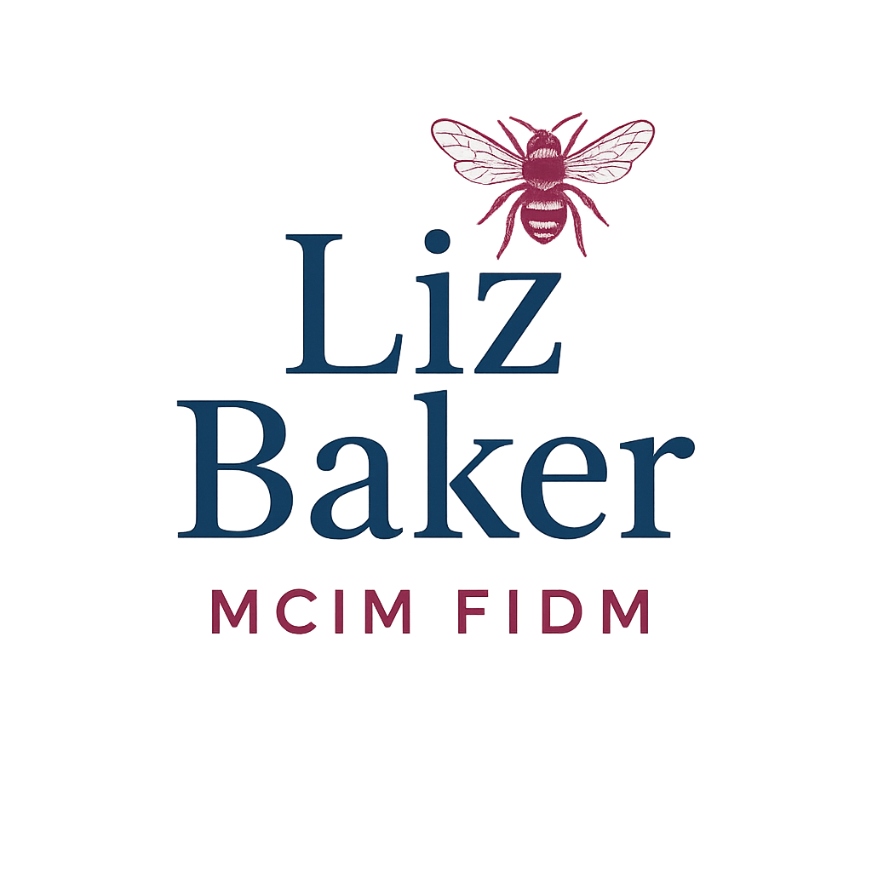
COMPANY NAME: Liz Baker MCIM FIDM |  | VERSION: Apr 2025
BRAND STYLE GUIDE
PH: 07958 186 842 | liz@lizbakermidm.uk |  | lizbakerfidm.uk

PRIMARY | SECONDARY | ACCENT | COPY | BACKGROUND
HEX: 184163 | HEX: 8C2748 | HEX: 6B3953 | HEX: 404040 | HEX: FFFFFF
RGB: 24 65 99 | RGB: 140 79 32 | RGB: 207 179 141 | RGB: 64 64 64 | RGB: 225 225 225

Liz combines strategic clarity with practical implementation – she’s both a thinker and a doer.

Intelligence behind every interaction

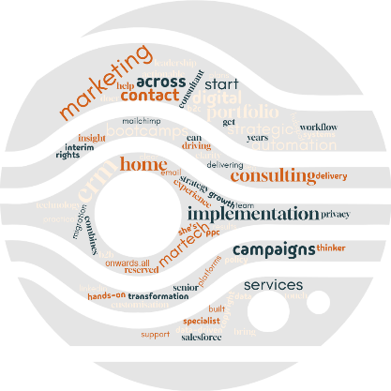
LOGOTYPE | Montserrat | Aa | Bb | Cc
TAGLINE | PT Sans | Aa | Bb | Cc
HEADLINE | Playfair / Garamond | Aa | Bb | Cc
BODY COPY | Montserrat | Aa | Bb | Cc

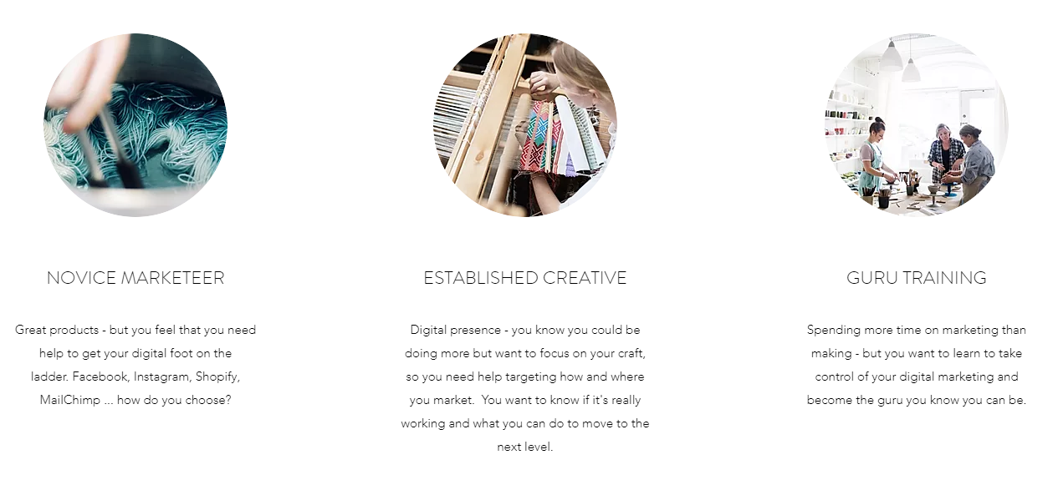
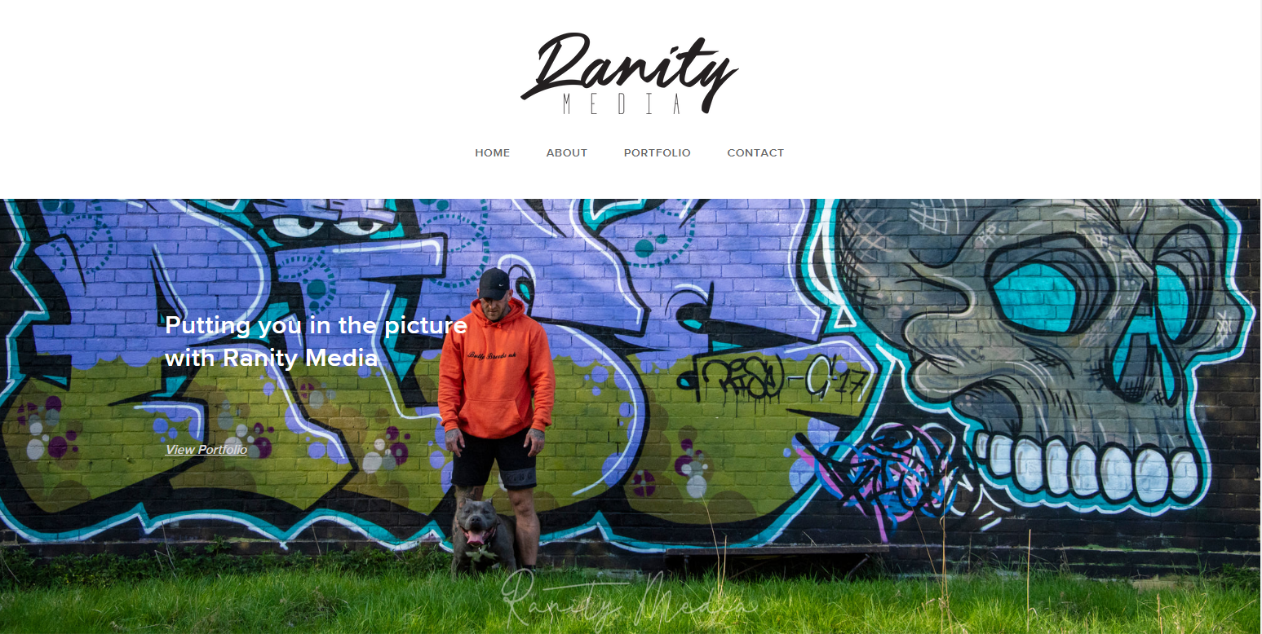

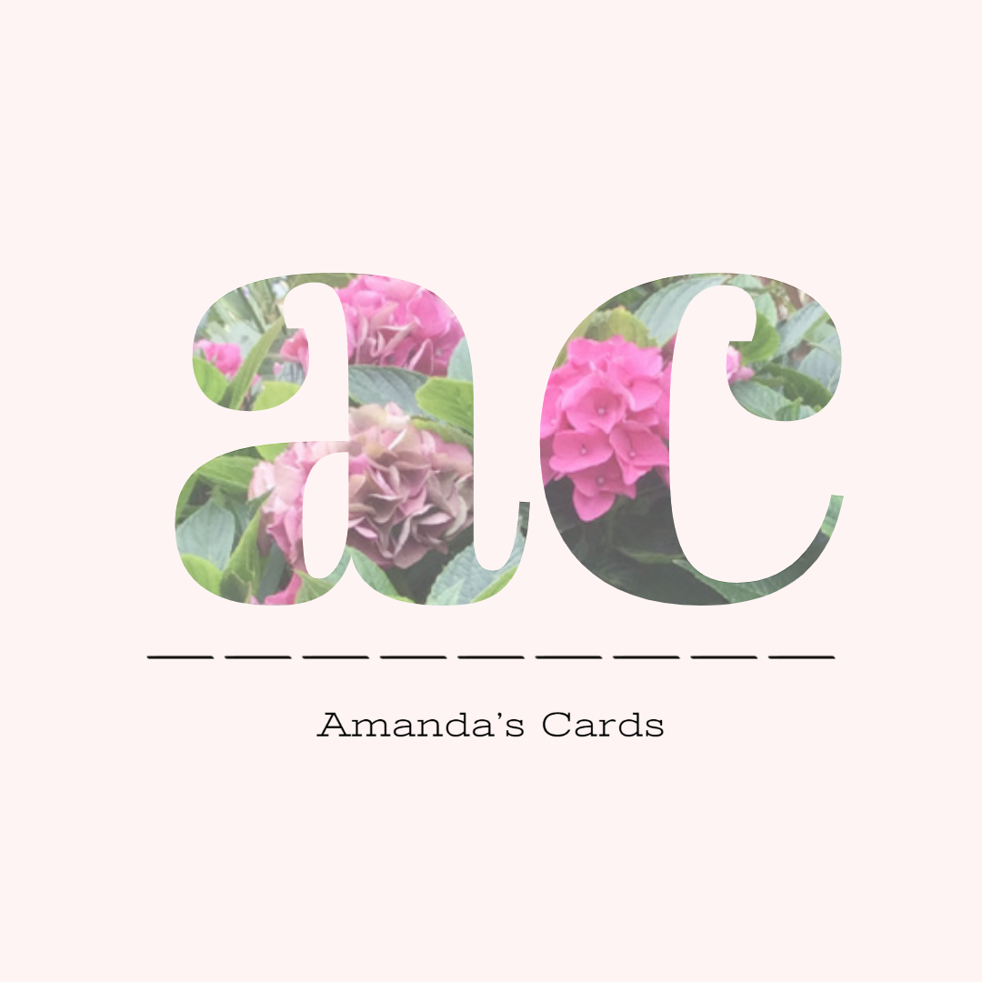

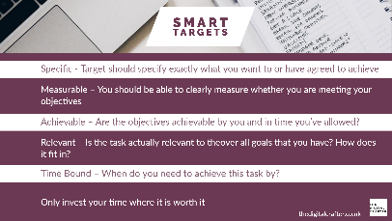
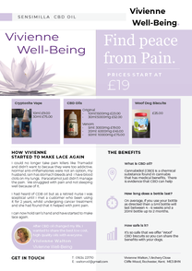


© lizbakerfidm.uk 2025

